Server Disk Space check

1. To check it for windows server by windows powershell on the server or run cmd from portal.

>> Get-PSDrive

1. Create a new disk attach to vm and check   
     
   >> create disk  
     
   A screenshot of a computer

   Description automatically generated

>>attach the disk to vm

Go to vm and navigate to disk section. Choose the disk to attach

1. Check the disk space  
     
   Note – the new added disk is not visible.

By Command-

>> Get-PSDrive

1. Add new added disk

Go to vm and navigate to disk manager, we can see the new added disk here.

Click on disk and create new volume the disk will be added.

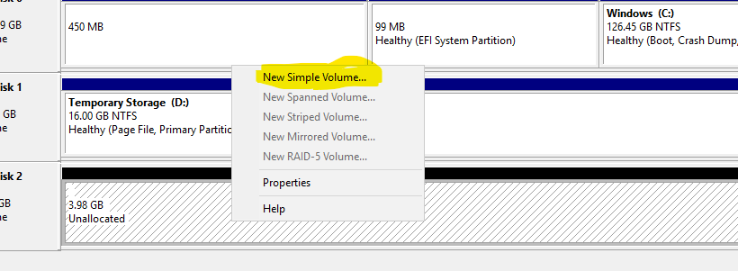

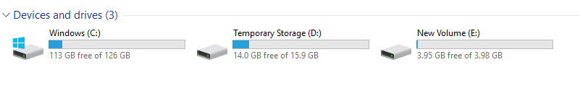

1. For linux vm cmd is >> df -h to check diskspace.
2. Not to run kql query and get data for example diskspace or any other we need log analytics workspace.  
     
   >> Create log analytics workspace

1. Connect the vm to Log Analytics workspace  
   Navigate to vm go to insight  
   enable insight. Create or choose Data collection rule if creating new rule choose log analytics workspace.

1. Once the insight is enabled run logs to see logs

1. Try log on log analytics workspace logs, make sure the vm is connected to the workspace.

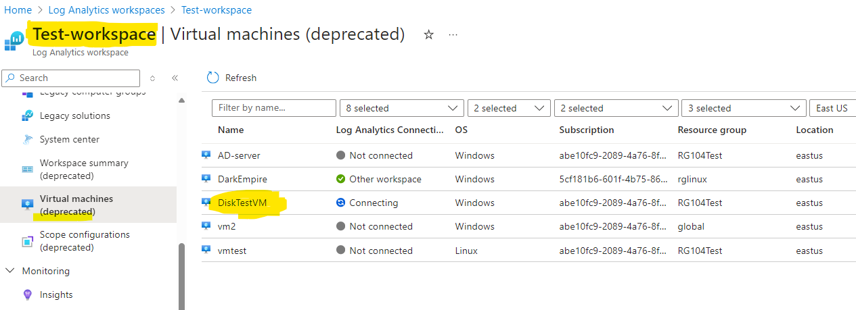

Heartbeat query works good.

1. Issue is we are able to see the heartbeat but not the cpu memory or others.

1. Verify data collection rule and check it’s logs to confirm everything works good.  
     
   A screenshot of a computer

   Description automatically generated
2. Troubleshooting steps  
     
   **Check agent status**: Verify that the Log Analytics agent is running on your VM. You can do this by running the following command in PowerShell or Command Prompt:

powershell

>> Get-Service | Where-Object { $_.DisplayName -eq "Microsoft Monitoring Agent" }

Res- **Status Name DisplayName**

**------ ---- -----------**

**Running HealthService Microsoft Monitoring Agent**

1. Check the resource has been configured properly.  
     
   A screenshot of a computer

   Description automatically generated
2. Issue has been resolved  
     
   Go to vm and navigate to diagnostic settings and review all required things.  
     
   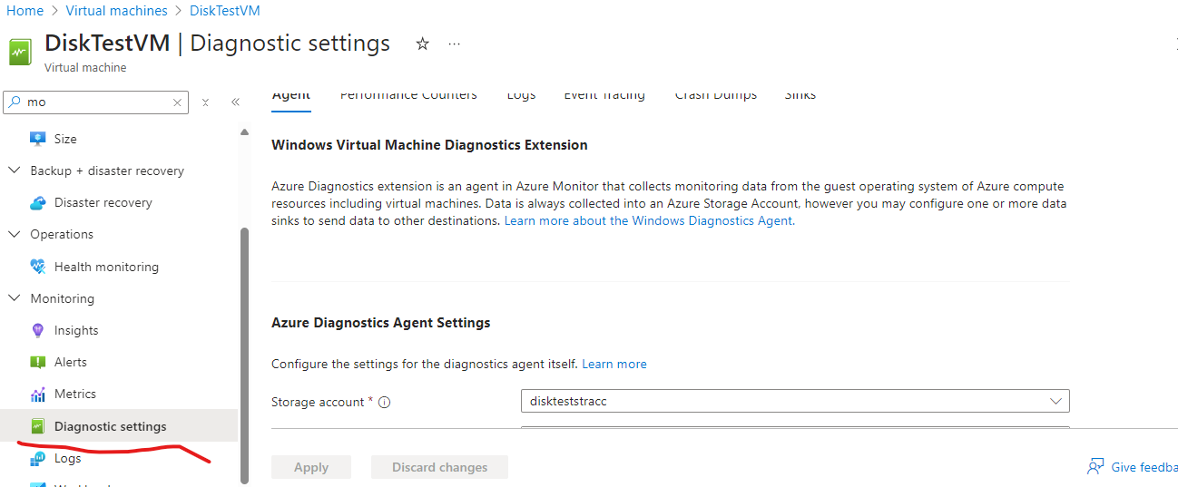

My issue was, I was not sending system logs to workspace. I have enabled that and that finally worked.  
  
query runs on vm as well  
  
1. Now I am creating a new vm and testing.  
   1. Created vm

2. connect the vm to log analytics workspace

3. still the vm is not found vm workspace  
  
 4. Enable performance Diagosnastic on vm  
   
5. enable system information logs

NOTE- here we do need to enable system verbose as well. Else we can’t get logs.  
  
 6. Still not able to see logs. Now configure insight for vm and configure data collection rule.

7. check the vm heartbeat is been received by workspace.

8. Check for disk space query

9. Still the new vm is not found.  
  
 now check for is vm sending logs to workspace  
  
 >> Perf

| summarize Count = count() by Computer

10. check data collection rule. I had added the vm to a wrong dcr so adding vm to correct dcr.

11. still not able to get. There was a issue with DCR, each time we need to create new for a vm.  
  
so creating new by selecting existing workspace  
  
Go to monitor -> insights -> enable  
  
if this enable option is not visible here go for azure monitor and then go for configuration  
  
We don’t have select existing DCR here so create now  
  
Make sure you choose correct workspace and create  
  
12. Go to new DCR and confirm everything working as expected.

13. now we can see the vm connected to workspace and logs query will work as expected  
  
**Query to check if the vm is sending logs to workspace**  
  
Perf

| summarize Count = count() by Computer

**Query to see all vms disks and usage**

let FreeMB = Perf

| where TimeGenerated > now(-10min) and CounterName == "Free Megabytes"

| summarize FreeMB = (avg(CounterValue)) by bin(TimeGenerated, 30min), Computer, InstanceName

| sort by TimeGenerated, Computer desc;

//FreeMB

let FreeSpace = Perf

| where TimeGenerated > now(-10min)

and CounterName == "% Free Space"

and InstanceName !contains "DPM"

| summarize FreeSpace = (avg(CounterValue)) by bin(TimeGenerated, 30min), Computer, InstanceName

| sort by TimeGenerated, Computer desc;

//FreeSpace

let DiskTotalFreeMB = FreeMB

| join kind=inner (FreeSpace) on Computer, InstanceName

| project TimeGenerated, Computer, InstanceName, FreeMB, FreeSpace

| extend TotalSizeGB = toint((FreeMB / FreeSpace * 100) / 1024);

//DiskTotalFreeMB

DiskTotalFreeMB

| sort by TimeGenerated, Computer, InstanceName

| where InstanceName != "_Total" and InstanceName !contains "HarddiskVolume"

| extend FreeDiskGB = FreeMB / 1024

| extend FreeDiskPercentage = (FreeDiskGB * 100) / TotalSizeGB

| project Computer, InstanceName, round(FreeDiskGB), FreeDiskPercentage, TotalSizeGB

| distinct Computer, InstanceName, round(FreeDiskGB), FreeDiskPercentage, TotalSizeGB

Query to check heart beat of a vm  
  
 Heartbeat

| where Computer == "DiskTestVM2"

| sort by TimeGenerated desc

Configure Alert for disk space usage on subscription level that will be usable for all vms

Navigate to portal and go to monitor and then navigate to alert to create alert

Select scope as subscription and then choose resource type virtual machine. There may be multiple virtual machines options. All are for different porpuse. For example vmss and more. Keep mouse curser on each option to see description and select correct one.

Mostly the last one is for vm.

Choose location of vm. Can select global so all region vm will be covered up.

Next go for custom logs search and provide query for log search

In my case I am giving query in such a way that it will trigger me am alert if any vm disk 5 % used and 95% is free.

You can provide value by providing the value at the “let PercentSpace = 95;”  
  
mostly for client we configure the alert will trigger if the free space is less then 5%.

Query->  
let PercentSpace = 99;

let FreeMB = Perf

| where TimeGenerated > now(-10min) and CounterName == "Free Megabytes"

| summarize FreeMB = (avg(CounterValue)) by bin(TimeGenerated, 30min), Computer, InstanceName

| sort by TimeGenerated, Computer desc;

//FreeMB

let FreeSpace = Perf

| where TimeGenerated > now(-10min)

and CounterName == "% Free Space"

and InstanceName !contains "DPM"

| summarize FreeSpace = (avg(CounterValue)) by bin(TimeGenerated, 30min), Computer, InstanceName

| sort by TimeGenerated, Computer desc;

//FreeSpace

let DiskTotalFreeMB = FreeMB

| join FreeSpace on Computer, InstanceName

| project TimeGenerated, Computer, InstanceName, FreeMB, FreeSpace

| extend TotalSizeGB = toint((FreeMB / FreeSpace * 100) / 1024);

//DiskTotalFreeMB

DiskTotalFreeMB

| sort by TimeGenerated, Computer, InstanceName

| where InstanceName != "_Total" and InstanceName !contains "HarddiskVolume"

| extend FreeDiskGB = FreeMB / 1024

| extend FreeDiskPercentage = (FreeDiskGB * 100) / TotalSizeGB

| where FreeDiskPercentage <= PercentSpace

| project Computer, InstanceName, round(FreeDiskGB), FreeDiskPercentage, TotalSizeGB

| distinct Computer, InstanceName, round(FreeDiskGB), FreeDiskPercentage, TotalSizeGB

Note- to reduce complexity of choosing vm category we can directly choose resource as subscription that will cover up all no need to choose category and all explicitly.  
  
Disadvantages- here vmss vm also may select which we don’t want to minitor.

Note- here I have given time 1 hr that will trigger alert in every 1 min. chose min 6hr for production.

Alert triggered to mail

Issue the alert was only triggering on 1 vm not on another, this is due to some unknown issue rebooting the vm resolved the issue.

if issue triggered make sure to install AMA agent as log analytes agent has been expeired.

How can we simplify it. Because it’s not possible to do same for each vm enabling insight enable performance diagosnastic.  
  
And how can we choose existing DCR while enabling insight

Issue- some times vm are showing logs on vm logs page but not on log analytics logs page.  
some glitch